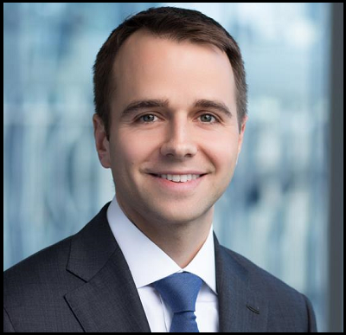
William Ridgway
Counsel, Litigation
Chicago Law Office of Skadden, Arps,
Slate, Meagher & Flom LLP
Chicago, IL
312-407-0449
william.ridgway@skadden.com

Prior to joining Skadden, Mr. Ridgway was an Assistant U.S. Attorney in the U.S. Attorney’s Office for the Northern District of Illinois, where he served as the Deputy Chief of the National Security and Cybercrimes Section. In this role, he oversaw and managed all of the office’s cybercrime, data breach and intellectual property cases. Mr. Ridgway also held the positions of National Security Cyber Specialist and Computer Hacking and Intellectual Property Coordinator for the U.S. Attorney’s Office.
In his eight years as a federal prosecutor, Mr. Ridgway tried numerous cases and handled a wide range of high-profile cybercrime and intellectual property cases, including the prosecution of an international cybercrime ring responsible for stealing over $100 million, as well as prosecutions of the leaders of two prominent hacking groups for hundreds of cyberattacks that targeted businesses, nonprofits and government bodies around the globe. Mr. Ridgway also led the prosecution of the operators of one of the world’s largest online piracy rings. Other notable matters Mr. Ridgway was involved in include several national security cases, as well as the prosecutions of a prominent Chicago restaurateur for corporate fraud, a leader of the Mexican Zetas cartel and his associates for money laundering, and an international document fraud ring for racketeering and murder.
Mr. Ridgway also argued a number of cases on appeal before the 7th and 2nd Circuits, including appeals involving matters of national security, the First Amendment and online freedom of speech, and the extraterritorial reach of the racketeering statute.
Mr. Ridgway has received numerous awards and recognition throughout his career, including the Director’s Award for Superior Performance from the Executive Office for United States Attorneys for prosecuting an international racketeering enterprise (2015) and the Chicago Crime Commission’s Stars of Distinction Award for the prosecution of criminal enterprises operating in Chicago (2009 and 2010). He also was selected as a Leadership Greater Chicago Fellow in its 2017 class.
Earlier in his career, Mr. Ridgway served as a law clerk for Hon. Vaughn R. Walker of the U.S. District Court for the Northern District of California and then for Hon. Richard A. Posner of the U.S. Court of Appeals for the 7th Circuit. Mr. Ridgway also has been a lecturer at University of Chicago Law School since 2011, where he teaches a class on cybercrime.

